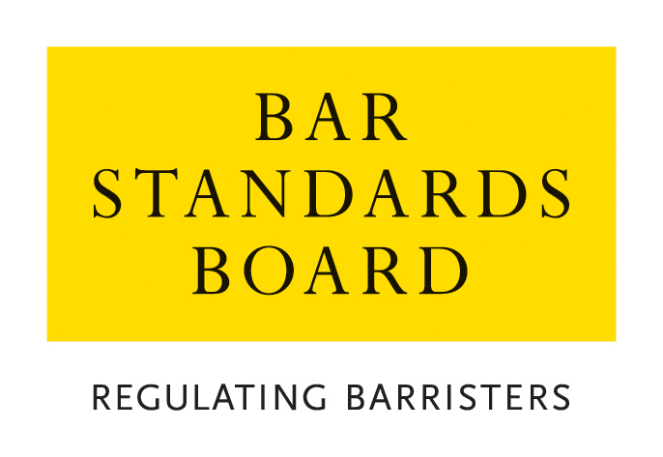

APPLICATION FOR REVIEW OF A DECISION OF THE BAR STANDARDS BOARD REGARDING THE ISSUE/AMENDMENT/REVOCATION OF A PRACTISING CERTIFICATE

CRITERIA AND GUIDELINES

A. Guidance Notes – General Procedure for applications and appeals
- General
  - In these Notes, the Bar Standards Board is referred to as “the BSB”. The BSB Handbook is referred to as “the Handbook”. The Bar Qualification Rules, which constitute Section 4B of the Handbook, are referred to as “BQR”
  - These Notes set out the criteria and guidelines which the BSB applies in considering applications and should be read carefully and in conjunction with the Handbook.
- Reviews and Appeals
  - The Practising Certificate Rules, at Section 3C of the Handbook, set out the requirements for a practising certificate. Rule S75 provides a review procedure for anyone who contends that the BSB has wrongly failed or refused to issue or amend a practising certificate or has wrongly amended or revoked a practising certificate.
  - Any request for a review must be made on the designated application form and accompanied by the relevant application fee within one month of notification of the relevant decision. All requests will be acknowledged in writing within seven days of receipt.
  - The Independent Decision-making Body (“IDB”) deals with reviews of decisions as if the application was being dealt with afresh. An IDB Panel shall be entitled to have regard to the original decision, and to affirm the decision under review or substitute any other decision which could have been made on the original application (rQ37.1).
  - All review requests are dealt with by an IDB Panel on the documents, only.
  - Applications for review are normally determined within 10 weeks of receipt. Should it not be possible to deal with a review within this timescale, the applicant will be notified.
  - All enquiries about reviews whether proposed or pending should be addressed to the BSB.
  - Where an IDB Panel has determined a review of a decision, there is no procedure under the BQR for an appeal to the Bar Standards Board from such determination. An IDB Panel may undertake a further review but is not obliged to do so. Any person dissatisfied with a determination of an IDB Panel is advised to take independent legal or other appropriate advice.
  - Rule Q39 provides that where the BQR provide for a review by the BSB of a decision, no appeal may be made to the High Court unless such a review has taken place.
  - Rule Q40 provides that subject to Rule Q39, a person or organisation who is adversely affected by a decision of the BSB may appeal to the High Court, in accordance with the Civil Procedure Rules.
- How applications are dealt with
  - Applications must be made on the current designated application form, available from the BSB’s website, and accompanied by the application fee.
  - Please return the completed application form with accompanying documentation and payment of the application fee to authorisations@barstandardsboard.org.uk. If you are unable to submit your application by email, please contact us for further guidance.
  - Applicants who may have particular difficulties in following the standard application procedure or need reasonable adjustments related to a disability may contact the BSB to discuss how these needs can be met.
  - All applications contain a declaration that the applicant has read, understood and complied with these Criteria and Guidelines.
  - The declaration must be completed with a hand-written signature. If you have no access to scan and print the application form - please write out the declaration from the application form by hand, sign it, take a photo of the document and email that to us as evidence of your handwritten signature.
  - An applicant must ensure that all supporting evidence is sent with the application form. We will accept copies of academic transcripts or professional confirmations emailed directly from the awarding body/regulator. If you are unable to provide documents by this method, please submit scans of your personal copies. We may contact the awarding body/regulator of any scanned documents provided directly by you to verify their content.
  - An application will not be treated as “complete” until the application form, required supporting documentation and application fee have been received. The BSB may request further information or documentation be supplied in support of an application, but applicants should note that it is the primary responsibility of the applicant to provide all relevant information and supporting evidence.
- Applicants should exercise judgement when selecting supporting evidence and ensure that only documentation relevant to the criteria set out in this document is supplied.
- It is usually not appropriate to supply examples of work with an application. Any applicant who does supply such examples should ensure that documents that refer to third parties (eg clients) are suitably redacted so as to ensure anonymity. Any application that is supported by unredacted material will be returned to the applicant.
  - The BSB will take into account all the circumstances of the particular application and will apply the guidelines set out in these Notes and the general outcome of the BQR set out at oQ1.
  - The BSB will treat all applications and any supporting documentation provided in the strictest confidence.
  - All enquiries about applications whether proposed or pending should be addressed to the BSB.
- Application Fees
4.1 All Review applications have a fee of £200, except for applications for review of a decision not to grant a fee waiver, for which there is no application fee payable.
  - Our preferred method of payment is bank transfer (BACS), the details for which are on our website.
If you are unable to pay by BACS, you may make payment by credit/debit card. Once you have received an email acknowledgement that your application has been logged, please call the Authorisations Team on 020 7611 1444 to make a card payment.
  - Details of our Fee Waiver policy are available on the BSB website.

Online Resources
BSB website: www.barstandardsboard.org.uk
Applications forms and guidance notes: https://www.barstandardsboard.org.uk/training-qualification/barrister-training-waivers-and-exemptions.html

Authorisation Team Service Update Page: www.barstandardsboard.org.uk/about-us/how-we-regulate/the-decisions-we-take/authorisations-decisions/authorisations-team-service-update.html

For further information, please contact the Authorisations Team on authorisations@barstandardsboard.org.uk or 020 7611 1444

B. Applications for the Issue of a Temporary Practising Certificate

- Rules and Procedures
1.1 Rule S76 allows the Bar Standards Board to issue a temporary practising certificate to a barrister who has lodged an application for review.
1.2 Applications for the issue of a temporary practising certificate should be made on the same application form as the application for review.
1.3 If a temporary practising certificate is issued it will usually be valid for three months from the date of issue.
- Criteria
The following approach will be taken where a barrister applies for a temporary practising certificate.
2.1 Circumstances in which a temporary practising certificate will not usually be granted
Where either
- the barrister did not hold a practising certificate that was valid on 31 March in the previous practising year, or
- the Bar Standards Board has revoked a practising certificate, or
- the Bar Standards Board has refused to amend a practising certificate,
then the barrister will generally not be issued with a temporary practising certificate, but the BSB may decide that there are features of the application that justify a departure from the usual practice and which justify the issue of a temporary practising certificate.
2.2 Circumstances in which a temporary practising certificate will usually be granted
Where either
- the barrister did hold a practising certificate that was valid on 31 March in the previous practising year and is applying for a renewal of that certificate, or
- the Bar Standards Board has amended a practising certificate,
then the barrister will generally be issued with a temporary practising certificate, but the BSB may decide that there are features of the application that justify a departure from the usual practice and which justify the refusal of a temporary practising certificate.

