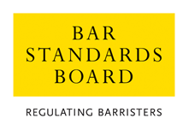

Application for Extension of Time for Completion of the New Practitioners Programme

PERSONAL DETAILS

Surname: |  |  | Other Names:
Correspondence Address:

Phone No:  Fax No: |  |  | Email:
Inn of Court: |  |  | Date of Call:
Date completed pupillage: |  |  | Date Commenced Practice:
Date due to complete the New Practitioners Programme:
NEW PRACTITIONERS PROGRAMME STATUS

 | Hours completed | Hours still to complete |  | Proposed dates for completion of courses
Advocacy
(6 hours or 9 hours if you commenced practice after 1/9/04)
Ethics
(3 hours)
Other CPD
(33 hrs)
Accountancy Course (can be completed during pupillage)
(20 hours)

NATURE OF APPLICATION

Please give full details of the extension you are requesting and why it is needed and your proposals for completion of your outstanding requirements within the time-extension requested:

Please continue on a separate sheet, if necessary.

OTHER INFORMATION

Please set out below any further information that you consider to be relevant to your application:

declarationS

Declaration by Applicant

1. I confirm that the information that I have provided is complete and accurate

2. Any supporting evidence that I have supplied with this application that refers to third parties has been suitably redacted so as to preserve their anonymity; and

3. I have read the Bar Council’s Privacy Statement and understand how my data will be handled.

Signed: |  | Date:

Declaration by Head of Chambers/Supervisor

I confirm that I have read the completed application form and support the application for an extension of time for completion of the New Practitioners Programme.

Signed: | Date:
Name: | Position:

PLEASE RETURN THE COMPLETED APPLICATION FORM WITH ACCOMPANYING DOCUMENTATION TO:

THE AUTHORISATIONS TEAM, REGULATORY OPERATIONS DEPARTMENT, THE BAR STANDARDS BOARD, 289-293 HIGH HOLBORN, LONDON WC1V 7HZ

authorisations@barstandardsboard.org.uk

The application fee for submitting an application seeking an extension of time is £135.00, for which the preferred method of payment is bank transfer (bacs), the details for which are available in the application guidelines.

The fee is non-refundable.

 | 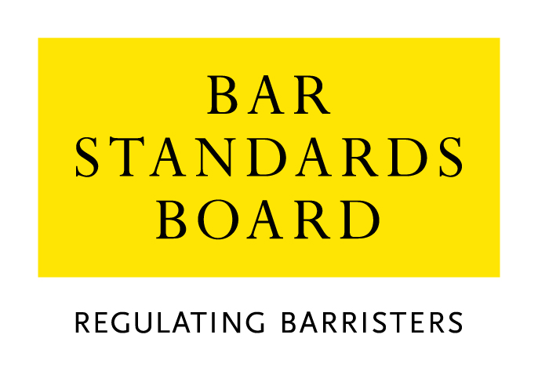

Equality & Diversity Monitoring Form

Diversity data gathered from this form will be anonymised and used to inform Bar Council and Bar Standards Board (BSB) policy aimed at widening access to the profession and improving diversity. It will assist the Bar Council and BSB in meeting our statutory duties under the Equality Act 2010 and will inform our wider equality and diversity strategy.

Your diversity data will be treated as confidential and stored securely according to the Bar Council’s Privacy policy. It will not be published in a way which might identify any individual. The raw data will be kept only for monitoring purposes.

Question formats are based on LSB approved monitoring questions.

Provision of diversity information is not compulsory however we strongly encourage you to help us by completing this form.

Please answer each question in turn by choosing one option only, unless otherwise indicated. If you do not wish to answer the question please choose the option ‘Prefer not to say’ rather than leaving the question blank.

1. Age

From the list of age bands below, please indicate the category that includes your current age in years:

16 - 24
25 - 34
35 - 44
45 - 54
55 - 64
65+
Prefer not to say

2. Gender

What is your gender?

Male
Female
Prefer not to say

3. Disability

The Equality Act 2010 generally defines a disabled person as someone who has a mental or physical impairment that has a substantial and long-term adverse effect on the person’s ability to carry out normal day-to-day activities.

(a) Do you consider yourself to have a disability according to the definition in the
Equality Act?

Yes
No
Prefer not to say

(b) Are your day-to-day activities limited because of a health problem or disability which has lasted, or is expected to last, at least 12 months?

Yes, limited a lot
Yes, limited a little
No
Prefer not to say

4. Ethnic group

What is your ethnic group?

Asian / Asian British

Bangladeshi
Chinese
Indian
Pakistani
Any other Asian background (write in)

Black / African / Caribbean / Black British

African
Caribbean
Any other Black / Caribbean / Black British (write in)

Mixed / multiple ethnic groups

White and Asian
White and Black African
White and Black Caribbean
White and Chinese
Any other Mixed / multiple ethnic background (write in)

White

British / English / Welsh / Northern Irish / Scottish
Irish
Gypsy or Irish Traveller
Any other White background (write in)

Other ethnic group

Arab
Any other ethnic group (write in)

Prefer not to say

Prefer not to say
5. Religion or belief

What is your religion or belief?

No religion or belief
Buddhist
Christian (all denominations)
Hindu
Jewish
Muslim
Sikh
Any other religion (write in)
Prefer not to say

6. Sexual orientation

What is your sexual orientation?

Bisexual
Gay man
Gay woman/lesbian
Heterosexual/straight
Other
Prefer not to say

7. Socio-economic background

(a) If you went to University (to study a BA, BSc course or higher), were you part of the first generation of your family to do so?

Yes
No
Did not attend University
Prefer not to say

(b) Did you mainly attend a state or fee paying school between the ages 11 – 18?

UK State School
UK Independent/Fee-paying School
Attended school outside the UK
Prefer not to say

8. Caring responsibilities

(a) Are you a primary carer for a child or children under 18?

Yes
No
Prefer not to say

(b) Do you look after, or give any help or support to family members, friends, neighbours or others because of either:

- Long-term physical or mental ill-health / disability
- Problems related to old age?

(Do not count anything you do as part of your paid employment)

No
Yes, 1 - 19 hours a week
Yes, 20 - 49 hours a week
Yes, 50 or more hours a week
Prefer not to say

Thank you for completing this questionnaire

See https://www.barstandardsboard.org.uk/privacy-statement.html

