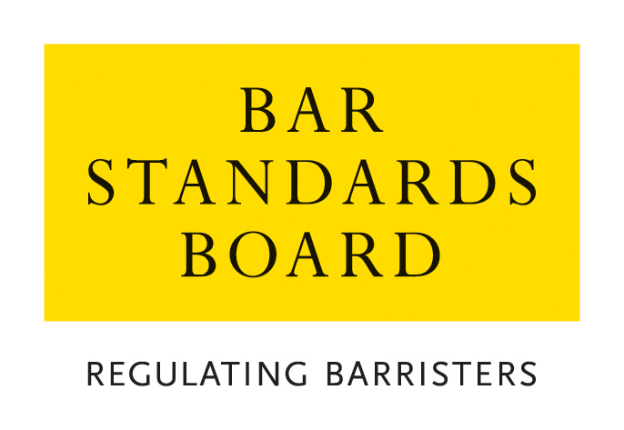

REGULATORY STANDARDS DEPARTMENT
AUTHORISATIONS TEAM

CRITERIA AND GUIDELINES FOR APPLICATIONS FOR DESIGNATION AS A LEGAL ADVICE CENTRE

These Notes are divided into two sections:
A. Guidance Notes – General Procedure for applications and appeals
B. Criteria for applications

Nature of Application | Brief Summary
- Designation as a Legal Advice Centre | This covers applications by legal advice centres for designation as suitable for the employment or attendance of barristers.

A. Guidance Notes – General Procedure for applications and appeals

1 General
  - In these Notes, the Bar Standards Board and its staff are referred to as the “the BSB”. The BSB Handbook is referred to as “the Handbook”. The Bar Qualification Rules, which constitute Section 4B of the Handbook, are referred to as “BQR”.
  - These Notes set out the criteria and guidelines which the BSB applies in considering applications and should be read carefully and in conjunction with the Handbook.
- How applications are dealt with
  - Applications must be made on the appropriate application form. Please return the completed application form with accompanying documentation and payment of the application fee to authorisations@barstandardsboard.org.uk. If you are unable to submit your application by email, please contact us for further guidance.
  - All applications contain a declaration that the applicant has read, understood, and complied with these Criteria and Guidelines.
  - The declaration must be completed with a hand-written signature. If you have no access to scan and print the application form - please write out the declaration from the application form by hand, sign it, take a photo of the document and email that to us as evidence of your handwritten signature.
  - Applications are considered and determined under the powers of the Bar Standards Board. The Bar Standards Board has delegated to BSB staff the ability to take decisions within the criteria and guidelines set out in this document.
  - An applicant must ensure that all supporting evidence is sent with the application form. Where original certificates or certified copies are required, these must be emailed directly to the BSB by the awarding institution.
  - An application will not be treated as “complete” until the application form, required supporting documentation and application fee have been received. The BSB may request further information or documentation be supplied in support of an application, but applicants should note that it is the primary responsibility of the applicant to provide all relevant information and supporting evidence.
- Applicants should exercise judgement when selecting supporting evidence and ensure that only documentation that is relevant to the criteria set out in this document is supplied.
It is usually not appropriate to supply examples of work with an application. Any applicant who does supply such examples should ensure that documents that refer to third parties (e.g. clients) are suitably redacted so as to ensure anonymity. Any application that is supported by unredacted material will be returned to the applicant.
  - The BSB will take into account all the circumstances of the particular application and will apply the guidelines set out in these Notes.
  - All applications will be acknowledged in writing within seven days of receipt of the complete application form.
  - The BSB normally deals with all applications within eight weeks of receipt and notifies applicants of its decision within 10 days of a decision.
  - The BSB will treat all applications and any supporting documentation provided in the strictest confidence.
  - All enquiries about applications whether proposed or pending should be addressed to the BSB.
- Application Fee Payment
  - The application fees for each type of application and methods of payment are listed on the BSB website. The preferred method of payment is bank transfer (BACS). Once your application has been logged by the Authorisations Team, an invoice will be generated and sent to you by email to enable you to make a BACS payment. You must quote the invoice reference when making a payment by BACS.
  - If you are unable to pay by BACS, you may make payment by credit/debit card. Once you have received an email acknowledgement that your application has been logged, please call the Authorisations Team on 020 7611 1444 to make a card payment.
  - Details of the team’s Fee Waiver policy are available on the BSB website.
- Reviews and Appeals
  - Any applicant who is dissatisfied with a decision may request a review of the decision.
  - Any request for a review must be made on the designated application form and accompanied by the relevant application fee within one month of notification of the relevant decision and must be accompanied by the appropriate application fee. All requests will be acknowledged in writing within seven days of receipt.
  - Review Panels deal with reviews of decisions as if the application was being dealt with afresh, applying the guidelines set out in these Notes. A Review Panel shall be entitled to have such regard to the original decision, and to uphold, vary or take into account such decision, as in its absolute discretion it feels appropriate.
  - Applications for review are normally determined within 10 weeks of receipt. Should it not be possible to deal with a review within this timescale, the applicant will be notified.
  - All enquiries about reviews whether proposed or pending should be addressed to the BSB.
  - Where a Review Panel has determined a review of a decision, there is no procedure under the BQR for a further review. A Review Panel may review its own decisions under section B10 of the BQR but is not obliged to carry out such a further review. Any person dissatisfied with a determination of a Review Panel is advised to take independent legal or other appropriate advice.
  - Rule Q39 provides that where the BQR provide for a review by the BSB of a decision, no appeal may be made to the High Court unless such a review has taken place.
  - Rule Q40 provides that subject to Rule Q39, a person or organisation who is adversely affected by a decision of the BSB may appeal to the High Court, in accordance with the Civil Procedure Rules.

Online Resources

BSB website: www.barstandardsboard.org.uk

Applications forms and guidance notes:
https://www.barstandardsboard.org.uk/qualifying-as-a-barrister/bar-training-requirements/forms-and-guidelines/applications-authorisations,-exemptions,-waivers-and-reviews/

Contact details: authorisations@barstandardsboard.org.uk

B. Criteria for applications

Designation as a Legal Advice Centre
Introduction
1.1 The application should be made on the appropriate prescribed form in typescript. Please note that applications will only be processed if made using the version of the appropriate application form current at the time the application is made. The completed application form should be accompanied by any relevant supporting documentation.
1.2 For details of the application fee and payment methods for designation as a Legal Advice Centre, please refer to the Bar Standards Board website: www.barstandardsboard.org.uk/qualifying-as-a-barrister/bar-training-requirements/forms-and-guidelines/applications-authorisations,-exemptions,-waivers-and-reviews/
Rules
1.3 Rules S39.8 and S41 of the Bar Standards Board Handbook allow a barrister to supply legal services to clients of a Legal Advice Centre.
1.4 The definition of a “Legal Advice Centre” is set out in Part 6 of the Handbook, as follows:
a centre operated by a charitable or similar non-commercial organisation at which legal services are habitually provided to members of the public without charge (or for a nominal charge) to the client and:
- which employs or has the services of one or more solicitors pursuant to rule 4.16 of the SRA Practice Framework Rules 2011, or
- which has been and remains designated by the Bar Standards Board as suitable for the employment or attendance of barristers subject to such conditions as may be imposed by the Bar Standards Board in relation to insurance or any other matter whatsoever
1.5 A Legal Advice Centre that does not employ a solicitor requires designation by the Bar Standards Board in order to employ a barrister to supply legal services to its clients.
Information and documentation
1.6 An applicant will be required to provide the following information and documentation:
1.6.1 Details of the work carried out by the organisation;
1.6.2 A copy of the last two annual reports issued by the organisation;
1.6.3 Details of the organisation’s indemnity insurance, including a copy of any up-to-date insurance certificates;
1.6.4 Details of the names of all barristers employed by, or attending at (i.e. on a voluntary basis) the organisation;
1.6.5 Details of complaints made against any of the barristers working for the organisation and how the complaints were resolved;
1.6.6 Details of the areas of law about which advice is given; and
1.6.7 A description of those people assisted by the organisation
Guidelines
1.7 The Bar Standards Board shall designate as a Legal Advice Centre an organisation that fulfils the following criteria:
1.7.1 The organisation is of charitable status or similar; and
1.7.2 The organisation offers advice to the public for free or for a nominal fee; and
1.7.3 The organisation has indemnity cover reasonably equivalent to that available to barristers from the Bar Mutual Indemnity Fund; and
1.7.4 The organisation is not an association formed for the benefit of its members; and
1.7.5 The organisation produces an annual report or similar.

