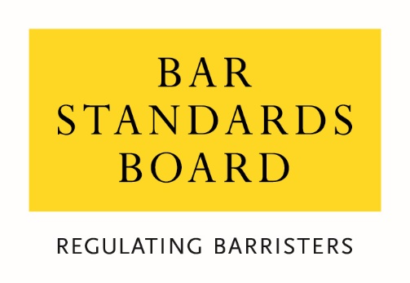

Consultation on proposed amendments to the definition of Academic Legal Training and related exemptions

January 2024

Consultation Questions
_____________________________________________________________________________________________________
Question 1:
Do you agree with our proposals for changing the definition of academic legal training as described in above in the first key change?

Question 2:
Do you agree with our proposal to remove Part 2 of the Bar Qualification Manual?

Question 3:
Do you agree with our proposal that Authorised Education and Training Organisations make admissions decisions based on the revised definition of academic legal training and in accordance with our guidance?

Question 4:
Do you agree with our proposal to no longer require Certificates of Academic Standing?

Question 5:
Are there any potential equality impacts that you think we have not considered?

Question 6:
If there is anything else you would like to comment on in relation to these proposals, please do so here.

- Your Name

- Your Organisation’s name (if applicable)

- Which of these groups best reflects you:

- Registered Barrister
- An unregistered Barrister who has previously practised
- An unregistered Barrister who has never practised
- Law student
- Education and Training provider
- Legal services consumer / member of the public
- Representative of legal consumers
- Other legal professional
- Legal services representative body
- Other (please specify)

- Are you responding in an individual capacity or as a representative of your organisation?
- Individual response
- Organisational response
Please give your name or the name of your organisation if you do not wish your response to be anonymous:

We will normally publish responses to consultations.
- If you would prefer to remain anonymous, please tell us.

Equality Monitoring Information We seek to monitor individual respondents to help us to understand the extent to which our consultations are being responded to by people from different backgrounds and so that we can understand where we need to do more to target the views of people from particular backgrounds. These questions are entirely optional and will be treated in the strictest confidence and in accordance with our privacy policy. If you are responding to this consultation as an individual, please complete the following questions:
- What is your age?
- Under 25
- 25-34
- 35-44
- 45-54
- 55-64
- Over 65
- Prefer not to say

- What is your sex?
- Female
- Male
- Prefer not to say

- Is your gender identity the same as the sex with which you were assigned at birth?
- Yes
- No
- Prefer not to say

- What best describes your gender?
- Female
- Male
- Prefer not to say
- I self-describe as

- Do you consider yourself to have a disability?
- Yes
- No
- Prefer not to say

- Is your ability to perform day-to-day activities limited because of a physical or mental disability, condition or illness, which has lasted or is expected to last for at least 12 months?
- Yes, a lot
- Yes, a little
- Not at all
- Prefer not to say

- What is your ethnic group?
- White – English/Welsh/Scottish/Northern Irish/British
- White – Irish
- White – Gypsy or Irish Traveller
- White – Roma
- White – I use a different term to describe my White ethnic background
- Asian/Asian British – Bangladeshi
- Asian/Asian British – Chinese
- Asian/Asian British – Indian
- Asian/Asian British – I use a different term to describe my Asian ethnic background
- Black/Black British – African
- Black/Black British – Caribbean
- Black/Black British – I use a different term to describe my Black ethnic background
- Mixed/Multiple Ethnic Background – White and Asian
- Mixed/Multiple Ethnic Background – White and Black African
- Mixed/Multiple Ethnic Background – White and Black Caribbean
- Mixed/Multiple Ethnic Background – White and Chinese
- Mixed/Multiple Ethnic Background – I use a different term to describe my Mixed/Multiple ethnic background
- Arab
- I use a different term to describe my ethnicity, which does not fall under “White”, “Asian”, “Black” or “Mixed/Multiple Ethnic Background”
- Prefer not to say

- What is your religion or belief?
- No religion
- Buddhist
- Christian
- Hindu
- Jewish
- Muslim
- Sikh
- Prefer not to say
- I have a different religion or belief

- Which of the following best describes your sexual orientation?
- Heterosexual
- Gay or Lesbian
- Bisexual
- Prefer not to say
- I use a different term

- Did you mainly attend a state or fee-paying school between the ages of 11 – 18?
- UK state school
- UK fee-paying school
- School outside UK
- Prefer not to say

- If you finished school after 1980, were you eligible for Free School Meals at any point during your school years?
- Yes
- No
- Not applicable
- Don’t know
- Prefer not to say

- If you went to university (to study a BA, BSc or higher), had either (or both) of your parents or carers attended university by the time you were 18?
- Yes
- No
- Don’t know
- I didn’t attend university
- Prefer not to say

- Are you a primary carer for a child or children under 18?
- Yes
- No
- Prefer not to say

- Do you look after, or give any help or support to family members, friends, neighbours or others because of either: long-term physical or mental ill-health/disability or problems relating to old age? (Do not count anything you do as part of paid employment).
- No
- Yes, 1-19 hours a week
- Yes, 20-49 hours a week
- Yes, 50 or more hours a week
- Prefer not to say

