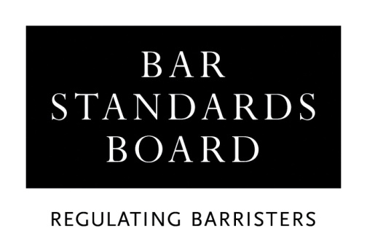

APPLICATION FOR A CERTIFICATE OF FULL/PARTIAL EXEMPTION FROM THE ACADEMIC COMPONENT OF TRAINING FOR THE BAR – ENGLAND AND WALES DEGREE PROVIDER

Before completing and submitting this form, you must read the accompanying guidelines in full, together with the Checklist.

Your application will not be processed until we have received all necessary supporting documents in the format specified in the application guidelines.

This form must be completed in type or BLOCK capitals.

All dates must be entered in full: ie, 00/00/00.

Full name:

(Please underline family name/surname)

Title: Miss / Mr / Mrs / Ms (delete as appropriate)

Address:

Telephone no.
Email address:

Date of birth:

Inn of Court (if known):

If you have been offered a place on a vocational component Bar Training Course, you must complete the following:

Year:

Institution:

Full-time / part-time / distance learning (delete as appropriate)

Details of the degree on which full/partial exemption is sought:

Degree title:

Degree subject:

Honours / ordinary (delete as appropriate)

Class of degree:

Name of institution:

Full-time / part-time / distance learning (delete as appropriate)

Period of study: (ie dates of commencement and award of degree)

Details of any other degree(s) held:

Degree title:

Degree subject:

Honours / ordinary (delete as appropriate)

Class of degree:

Name of institution:

Full-time / part-time / distance learning (delete as appropriate)

Period of study: (ie dates of commencement and award of degree)

I wish to claim exemption from the following Foundations of Legal Knowledge subjects in respect of subjects passed in the degree(s) detailed on the previous page.

Please place an ‘x’ in the relevant column to mark the subjects from which exemption is sought and enter the full date on which that assessment was passed under ‘Date passed’. You must not mark subjects which are outstanding: ie those which you intend to undertake within the GDL.

Subject | X | Date passed | Subject | X | Date passed
Obligations I (Contract) |  |  | Public Law  (Constitutional & Administrative Law)
Obligations II (Tort) |  |  | Equity & The Law of Trusts
Criminal Law |  |  | European Union Law
Property Law (Land Law) |  |  | Another Area of Legal Study  Title of subject claimed:

In addition, I wish to claim exemption from English Legal System

(Please state the title of this subject as shown on your transcript):

Please refer to the section of the guidance notes relating to Another Area of Legal Study and English Legal System before completing these sections.

I intend to complete the academic component of Bar training by passing the GDL:

Institution | Subjects | From | To
Expected/Actual Date of Completion: | Mode of study:  Full-time / part-time / distance learning  (delete as appropriate)

Please note that you may not commence a vocational component Bar Training Course unless and until you have satisfactorily completed the academic component of Bar training.

DECLARATION

I declare that:
- I have read the application criteria and guidelines;
- The information that I have provided is complete and accurate;
- Any supporting evidence that I have supplied with this application that refers to third parties has been suitably redacted so as to preserve their anonymity;
- I am submitting this application with the intention of undertaking the academic component of training for the Bar, and;
- I have read the Bar Council’s Privacy Statement and understand how my data will be handled.

Signature
Name
Date

PLEASE RETURN THE COMPLETED APPLICATION FORM WITH ACCOMPANYING DOCUMENTATION AND PAYMENT OF THE APPLICATION FEE TO:

THE AUTHORISATIONS TEAM, REGULATORY OPERATIONS DEPARTMENT, THE BAR STANDARDS BOARD, 289-293 HIGH HOLBORN, LONDON WC1V 7HZ

authorisations@barstandardsboard.org.uk

The fee is non-refundable.
Please forward this pro-forma to your university, requesting that it be completed and signed by the Head of Law, or the Registry Office, then forwarded to the BSB along with your transcript in a sealed envelope or by direct email. Open copies are not acceptable.

If, for any reason, your university is unable to sign this pro-forma, you must request the relevant member of academic staff to provide a full explanation for this as your application for exemption cannot be assessed unless and until this pro-forma has been completed and returned, or an explanation, as stated above has been received.

I confirm that [applicant name]:

has passed the Foundation(s) of Legal Knowledge subject(s) indicated below at [institution name]:

and that this/these subject(s) have been studied and examined to both the same coverage and level as those within a single-honours Law Degree course at this institution.

Subject | Year  Passed | Subject | Year Passed
Obligations I (Contract) |  | Public Law  (Constitutional & Administrative Law)
Obligations II (Tort) |  | Equity & The Law of Trusts
Criminal Law |  | European Union Law
Property Law (Land Law) |  | Another Area of Legal Study  Subject Title:
English Legal System

Signature

Name

Position/Job Title

Date

University stamp or seal:

Checklist

A student is not eligible to commence the vocational component of Bar training (ie a Bar Training Course) unless and until that student has satisfactorily completed the academic component or has been granted a waiver to commence the vocational component by the Bar Standards Board. To ensure that this requirement is met, applicants intending to undertake the vocational component must allow at least eight weeks for the processing of this application.

Before returning this form, you must ensure that you have:

- Provided a certified copy (please see notes on completing application form) of the relevant documentation, if for any reason, you have changed your family name/surname since your degree was awarded:

- Enclosed evidence of the degree(s) upon which your full/partial exemption application is based together with evidence of any other degree(s) listed on this form which must be in the form of official transcripts. You must refer to the transcript format requirements section of the guidance notes before submitting transcripts. If necessary, it is acceptable for you to request that these documents are sent directly to the Bar Standards Board (BSB) by the awarding institution; however, the BSB will not contact third parties for this, or any other purpose;

- Enclosed the completed form from the Head of Law, or the Registry Office, as requested in the guidance notes;

- Completed and dated the application form. The form may be submitted in hard copy or by email; however, you must sign the application declaration by hand, as typed signatures are not acceptable;

- Indicated the subjects from which exemption is sought, including Another Area of Legal Study and English Legal System, if appropriate;

- Completed the Equal Opportunities Monitoring form, if willing to do so, and;

- Provided the fee of £275.00. Please refer to the current application guidelines for details of acceptable payment methods.

Unless specifically requested by ticking one of the boxes below, any documents provided in support of an application will be destroyed through the Bar Standards Board’s (BSB) confidential waste procedures.

□ I wish for my documents to be returned in the pre-paid self-addressed envelope provided by me

□ I wish for my documents to be returned by ordinary post

 | 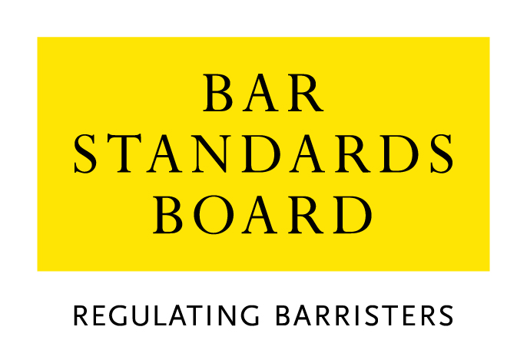

Equality & Diversity Monitoring Form

Diversity data gathered from this form will be anonymised and used to inform Bar Council and Bar Standards Board (BSB) policy aimed at widening access to the profession and improving diversity. It will assist the Bar Council and BSB in meeting our statutory duties under the Equality Act 2010 and will inform our wider equality and diversity strategy.

Your diversity data will be treated as confidential and stored securely according to the Bar Council’s Privacy policy. It will not be published in a way which might identify any individual. The raw data will be kept only for monitoring purposes.

Question formats are based on LSB approved monitoring questions.

Provision of diversity information is not compulsory however we strongly encourage you to help us by completing this form.

Please answer each question in turn by choosing one option only, unless otherwise indicated. If you do not wish to answer the question please choose the option ‘Prefer not to say’ rather than leaving the question blank.

1. Age

From the list of age bands below, please indicate the category that includes your current age in years:

16 - 24
25 - 34
35 - 44
45 - 54
55 - 64
65+
Prefer not to say

2. Gender

What is your gender?

Male
Female
Prefer not to say

3. Disability

The Equality Act 2010 generally defines a disabled person as someone who has a mental or physical impairment that has a substantial and long-term adverse effect on the person’s ability to carry out normal day-to-day activities.

(a) Do you consider yourself to have a disability according to the definition in the
Equality Act?

Yes
No
Prefer not to say

(b) Are your day-to-day activities limited because of a health problem or disability which has lasted, or is expected to last, at least 12 months?

Yes, limited a lot
Yes, limited a little
No
Prefer not to say

4. Ethnic group

What is your ethnic group?

Asian / Asian British

Bangladeshi
Chinese
Indian
Pakistani
Any other Asian background (write in)

Black / African / Caribbean / Black British

African
Caribbean
Any other Black / Caribbean / Black British (write in)

Mixed / multiple ethnic groups

White and Asian
White and Black African
White and Black Caribbean
White and Chinese
Any other Mixed / multiple ethnic background (write in)

White

British / English / Welsh / Northern Irish / Scottish
Irish
Gypsy or Irish Traveller
Any other White background (write in)

Other ethnic group

Arab
Any other ethnic group (write in)

Prefer not to say

Prefer not to say
5. Religion or belief

What is your religion or belief?

No religion or belief
Buddhist
Christian (all denominations)
Hindu
Jewish
Muslim
Sikh
Any other religion (write in)
Prefer not to say

6. Sexual orientation

What is your sexual orientation?

Bisexual
Gay man
Gay woman/lesbian
Heterosexual/straight
Other
Prefer not to say

7. Socio-economic background

(a) If you went to University (to study a BA, BSc course or higher), were you part of the first generation of your family to do so?

Yes
No
Did not attend University
Prefer not to say

(b) Did you mainly attend a state or fee paying school between the ages 11 – 18?

UK State School
UK Independent/Fee-paying School
Attended school outside the UK
Prefer not to say

8. Caring responsibilities

(a) Are you a primary carer for a child or children under 18?

Yes
No
Prefer not to say

(b) Do you look after, or give any help or support to family members, friends, neighbours or others because of either:

- Long-term physical or mental ill-health / disability
- Problems related to old age?

(Do not count anything you do as part of your paid employment)

No
Yes, 1 - 19 hours a week
Yes, 20 - 49 hours a week
Yes, 50 or more hours a week
Prefer not to say

Thank you for completing this questionnaire

See https://www.barstandardsboard.org.uk/privacy-statement.html

