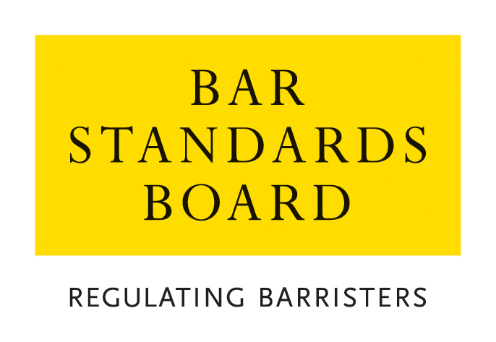

Application for Authorisation as a Licensed Access Client

Applicant organisation
Contact Name:
Name of Organisation:
Address:

Tel: |  | Fax:
Email address:
Please indicate with a tick what type of organisation this is:
Sole Trader |  | Advice Bureau or Agency
Partnership
Company |  | Public Authority
Association |  | Authorised Regulatory Authority/Agency
Charity |  | Chartered Institute/Society
Other:

Brief Description of Organisation:

LICENCE REQUESTED
Do you wish to use licensed access for:
Advice |  | Advocacy
Arbitration |  | Adjudication
Mediation
Other (please specify):
Please supply brief details of the type of case in which you wish to instruct a barrister:

Do you wish to instruct a barrister directly: Y/N
On behalf of your organisation
On behalf of employees of the organisation
On behalf of customers/clients of the organisation
On behalf of others (please give details)

FURTHER INFORMATION REQUIRED FROM ORGANISATIONS WISHING TO INSTRUCT ON BEHALF OF THIRD PARTIES (employees, clients etc)
Please supply details of the services that you provide to third parties and the circumstances in which this may involve instructing a barrister on their behalf.

Is your organisation registered with the Information Commissioner’s Office (ICO)? (Y/N)
Do you intend to receive monies from third parties on trust? (Y/N)
If yes, please enclose an accountant’s certificate that you have financial structures and procedures in place that are satisfactory for the purpose of keeping monies held on trust separate from monies of your organisation.
Do you or your organisation hold professional negligence insurance? (Y/N)
If yes, please attach details of insurer, nature of risk insured, amount and policy details

PROPOSED USERS OF THE LICENCE
Name | Job Title | If this person is governed by any regulatory authority, please give details. | Has this person ever been convicted of a criminal offence?* | Has this person ever been adjudged bankrupt, made a composition with his/her creditors or been sued to judgement for any debt, or are any such proceedings pending?* | Has this person ever been subject to the disciplinary process of any regulatory or professional body or trade association where the matter has not been dismissed, or are any such proceedings pending?*
*If the answer to any of these questions is “yes”, please supply full details on a separate sheet

PROPOSED USERS OF THE LICENCE

Please do not complete this section if you are applying on behalf of a public authority, authorised regulatory authority/agency or chartered institute/society.

Other applicants should complete this section and please also supply a CV for each individual in addition to completion of this section.

Name | Relevant training and experience

DECLARATION (to be signed by a member of the governing body of the organisation, ie a member of the Board of Directors, Trustee, Chief Executive or equivalent)

I confirm that the above named individuals are authorised (if a licence is issued by the Bar Standards Board) by the organisation to use the licensed access scheme on behalf of the organisation.

I confirm that the information provided on this form is true to the best of my knowledge and that any change whether arising before a licence is granted or during the currency of a licence will be notified immediately to the Bar Standards Board.

I have read the Bar Council’s Privacy Statement and understand how the data I have provided will be handled.

Signed
Name
Position in Organisation
Date

Please return this form, with the current application fee to:

Authorisations Team
Regulatory Operations Department
The Bar Standards Board
289-293 High Holborn
London
WC1V 7HZ

DX 240 LDE

authorisations@barstandardsboard.org.uk

The fee is non-refundable.

See https://www.barstandardsboard.org.uk/privacy-statement.html

