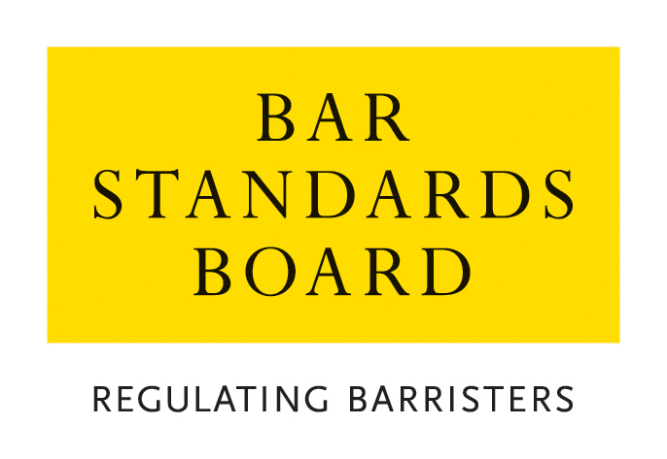

REGULATORY OPERATIONS DEPARTMENT
AUTHORISATIONS TEAM

CRITERIA AND GUIDELINES FOR GENERAL EXEMPTION FROM TRAINING REQUIREMENTS

These Notes are divided into two sections:

Section A. Guidance Notes – General Procedure for applications and appeals
Section B. Criteria for applications

Nature of Application | Brief Summary
- Applications for General Exemption from Training Requirements | Application for general exemption from the requirements for the academic and/or vocational and/or work-based learning (pupillage) components of Bar training
A. Guidance Notes – General Procedure for applications and appeals

1 General
  - In these Notes, the Bar Standards Board and its staff are referred to as the “the BSB”. The BSB Handbook is referred to as “the Handbook”. The Bar Qualification Rules, which constitute Section 4B of the Handbook, are referred to as “BQR”.
  - These Notes set out the criteria and guidelines which the BSB applies in considering applications and should be read carefully and in conjunction with the Handbook.
- How applications are dealt with
  - Applications must be made on the current designated application, available from the BSB’s website, and accompanied by the relevant application fee.
  - Applications may either be submitted as hard-copies by post or as scanned copies by email. All applications must contain a hand-written signature.
  - The application fees for each type of application are listed on the BSB website. The preferred method of payment is bank transfer (BACS), the details for which are:
Bank Name: | Royal Bank of Scotland
Branch Name: | Childs, Fleet Street
Sort Code: | 15-80-00
Account No: | 62428522
Account Name/Alias: | General Council of the Bar
Currency: | GBP
Bank Identifier Code (BIC): | RBOSGB2L
International Bank Account No (IBAN): | GB60RBOS15800062428522
When paying by BACS, you must ensure with your bank that the BSB receives the full amount in Sterling: ie, you must pay all charges of your bank and agents charges, including those of the BSB. This may include a handling charge levied by RBS if the issuing bank does not pay all bank charges.
- Please put a reference of “AUTH” against your name on the transaction to help identify the payment.
- Please provide proof of payment/a copy of your payment receipt with your application.
- If someone else is paying the fee on your behalf, please confirm the name of the person making the payment and any reference quoted.
If you are unable to pay by BACS, you may submit payment by cheque (made payable to the ‘Bar Standards Board’) or by credit/debit card. Please call the Authorisations Team on 020 7611 1444 to make a card payment.
Details of the Fee Waiver Policy are available on the BSB website.
  - All applications contain a declaration that the applicant has read, understood and complied with these Criteria and Guidelines.
  - Applications are considered and determined under the powers of the Bar Standards Board. The Bar Standards Board has delegated to BSB staff the ability to take decisions within the criteria and guidelines set out in this document.
  - An applicant must ensure that all supporting evidence is sent with the application form. Where original certificates or certified copies are required, these must be sent in hard-copy or emailed directly to the BSB by the awarding institution.
- Any hard-copy documents will be scanned upon receipt. To facilitate this process, please ensure that documents supplied with an application are not stapled or submitted in individual plastic wallets.
- If an application requires their original documents to be returned, they must provide a pre-paid envelope for this purpose. If the documents are to be returned by courier, it is the applicant’s responsibility to arrange for the courier and pay any necessary charges.
  - An application will not be treated as “complete” until the application form, required supporting documentation and application fee have been received. The BSB may request further information or documentation be supplied in support of an application, but applicants should note that it is the primary responsibility of the applicant to provide all relevant information and supporting evidence.
- Applicants should exercise judgement when selecting supporting evidence and ensure that only documentation that is relevant to the criteria set out in this document is supplied.
It is usually not appropriate to supply examples of work with an application. Any applicant who does supply such examples should ensure that documents that refer to third parties (e.g. clients) are suitably redacted so as to ensure anonymity. Any application that is supported by unredacted material will be returned to the applicant.
  - The BSB will take into account all the circumstances of the particular application and will apply the guidelines set out in these Notes.
  - All applications will be acknowledged in writing within seven days of receipt of the complete application form.
  - The BSB normally deals with all applications within eight weeks of receipt and notifies applicants of its decision within 10 days of a decision.
  - The BSB will treat all applications and any supporting documentation provided in the strictest confidence.
  - All enquiries about applications whether proposed or pending should be addressed to the BSB.
- Reviews and Appeals
  - Any applicant who is dissatisfied with a decision may request a review of the decision.
  - Any request for a review must be made on the designated application form and accompanied by the relevant application fee within one month of notification of the relevant decision and must be accompanied by the appropriate application fee. All requests will be acknowledged in writing within seven days of receipt.
  - Review Panels deal with reviews of decisions as if the application was being dealt with afresh, applying the guidelines set out in these Notes. A Review Panel shall be entitled to have such regard to the original decision, and to uphold, vary or take into account such decision, as in its absolute discretion it feels appropriate.
  - Applications for review are normally determined within 10 weeks of receipt. Should it not be possible to deal with a review within this timescale, the applicant will be notified.
  - All enquiries about reviews whether proposed or pending should be addressed to the BSB.
  - Where a Review Panel has determined a review of a decision, there is no procedure under the BQR for a further review. A Review Panel may review its own decisions under section B10 of the BQR but is not obliged to carry out such a further review. Any person dissatisfied with a determination of a Review Panel is advised to take independent legal or other appropriate advice.
  - Rule Q39 provides that where the BQR provide for a review by the BSB of a decision, no appeal may be made to the High Court unless such a review has taken place.
  - Rule Q40 provides that subject to Rule Q39, a person or organisation who is adversely affected by a decision of the BSB may appeal to the High Court, in accordance with the Civil Procedure Rules.

Online Resources
BSB website: www.barstandardsboard.org.uk
Applications forms and guidance notes: www.barstandardsboard.org.uk/training-qualification/barrister-training-waivers-and-exemptions.html

Contact details
authorisations@barstandardsboard.org.uk

Authorisations Team
Regulatory Operations Department
Bar Standards Board
289-293 High Holborn
London
WC1V 7HZ
DX: 240 LDE
Tel: 020 7611 1444
B. Criteria for Applications

1. | Application for General Exemption from Training Requirements
Introduction
1.1 Rule Q7 provides that the Board may grant exemptions from part, or all, of:
(a) the Academic Component
(b) the Vocational Component, and/or
(c) the Work-based Learning (pupillage) Component,
of training.
1.2 For details of the application fee, please refer to the Bar Standards Board website: www.barstandardsboard.org.uk/training-qualification/barrister-training-waivers-and-exemptions.html
Details
1.3 An exemption from part, or all, of any component of training may be granted unconditionally or subject to conditions, which may include in an appropriate case:
(a) a requirement to undertake training in substitution for training prescribed by these regulations; and/or
(b) a condition that the applicant must pass a Bar Transfer Test.
When considering what conditions to impose, the BSB will have regard to all relevant circumstances of the particular applicant.
Information and Documentation
1.4 The application must contain or be accompanied by the following:
1.4.1 Details of the applicant’s educational and professional qualifications and experience
1.4.2 Evidence (where applicable) that the applicant is or has been entitled to exercise rights of audience before any court, specifying the rights concerned and the basis of the applicant’s entitlement to exercise such rights
1.4.3 Any other representations or evidence on which the applicant wishes to rely in support of the application
1.4.4 Verified English translations of every document relied on which is not in the English language
Guidelines
1.5 From 1 September 2020, all prospective barristers are required to complete 10 Qualifying Sessions which are organised by their Inn in accordance with the Framework for the provision of Qualifying Sessions before they are Called to the Bar. Applicants should contact their Inn for further details of the sessions on offer.
1.6 The BSB will have principal regard to the following:
1.6.1 The grant of an exemption from part, or all, of any one of the three components of training is a discretionary and exceptional course, because the BQR provide that the components must be completed in full.
1.6.2 In exercising any discretion whether to grant an exemption, the BSB will determine whether the relevant knowledge and experience of the applicant make it unnecessary for the applicant to undertake such training.
1.6.3 The BSB will have particular regard to the extent to which an applicant demonstrates satisfaction of the Threshold Standard described for each of the competencies of the BSB’s Professional Statement. Further details can be found on this page of the BSB’s website: www.barstandardsboard.org.uk/training-qualification/the-professional-statement.html

1.7 Because of the wide-ranging nature of potential circumstances which might suggest that an application is exceptional, it is not possible to set out any definitive guidance as to particular instances when the BSB would be prepared to exercise its discretion and grant an exemption. The BSB will take into account all the particular circumstances of the case in coming to a decision.

