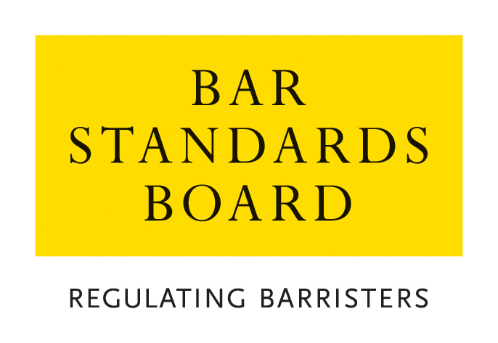

Application for Registration as a European Lawyer under the European Establishment Directive 98/5/EC

1. Personal Details

Surname

Other names

Title

(eg Mr, Ms)

Address
Telephone no.
Email Address

Nationality

Professional Title in Home Member State

2. Details of Home Jurisdiction

Please give the name and address of the competent authority with which you are registered as a lawyer in your home jurisdiction. If more than one, please give the name and address for each.
Name of Competent Authority 1

Address

Date of Admission

Name of Competent Authority 2

Address

Date of Admission

3. Current Status
Have you completed your training?
Are you currently entitled to practice as a member of the legal profession to which you belong?
Is the certificate of attestation from your home jurisdiction and any other jurisdiction attached?
Are you currently covered by professional indemnity insurance?
If yes, please provide details, including conditions and extent of cover, on a separate sheet of paper.

4. Previous Applications
Have you previously made an application for registration under the Establishment Directive:
To the Bar Council/Bar Standards Board?
To the Law Society/Solicitors Regulation Authority?
In another jurisdiction
If yes, please supply full details, including the outcome of the application.

5. Material Events
Have formal proceedings alleging professional misconduct by you been started before a court or disciplinary tribunal in any jurisdiction?

Have you ever been struck off or suspended from practice in any jurisdiction as a result of disciplinary proceedings?

Have you suffered from any other disciplinary sanctions?
Are there any material events relating to your fitness to practice which have occurred since your last application (if any) for registration (eg bankruptcy)?

If you have answered yes to any of the above, please provide full details.

6. Declaration

I declare that*:
i) I am of good character and repute

ii) I have not on the ground of professional misconduct or the commission of any criminal offence been prohibited from practising in any jurisdiction in relation to which I am a qualified legal practitioner and I am not currently suspended from so practising;

iii) No bankruptcy order or directors disqualification order has been made against me and I have not entered into an individual voluntary arrangement with my creditors;

iv) I am not aware of any other circumstances relevant to my fitness to practise under my home title in England and Wales;

v) I am not currently registered with the Law Society of England and Wales, of Scotland or of Northern Ireland;

vi) The information that I have provided is complete and accurate;

vii) Any supporting evidence that I have supplied with this application that refers to third parties has been suitably redacted so as to preserve their anonymity;

viii) I have disclosed to the Bar Standards Board in writing any circumstances affecting me which might reasonably be considered to be relevant to the question whether I should be registered as a European Lawyer;

ix) I agree to abide by the rules of professional conduct of the BSB/BC during the period of registration and I also agree that my home Bar(s)/Law Societies and the BSB/BC can freely exchange all relevant information about my professional activities; and

x) I have read the Bar Council’s Privacy Statement and understand how my data will be handled.

*If you are unable to make any part of this declaration, please delete
that part clearly and provide full details on a separate sheet.

Signature

Date

CHECKLIST

Please enclose with this form:

- A certificate, not more than three months old, proving the applicant’s registration with the competent authority in the applicant’s home Member State as a lawyer qualified to practise under the applicant’s home country professional title
- Evidence to show that the applicant is of good character and repute
- Evidence that the applicant is not suspended or prohibited from practising in the applicant’s Member State by virtue of professional misconduct or commission of a criminal offence
- Evidence that the applicant has not been adjudicated bankrupt or been the subject of a similar order in any jurisdiction
- Evidence of the professional body of which the applicant is a member in the applicant’s home Member State and of the judicial authority before which the applicant is entitled to practise
- Evidence that the applicant holds professional indemnity insurance equivalent to the insurance required by the Bar Code of Conduct
- Certified translations of every certificate and other document on which the applicant relies which is not in the English language.
- Current application fee. Please refer to the guidance notes for the appropriate fees and payment method.

Please confirm how you wish your original documents to be returned:

□ I wish for my documents to be returned in the pre-paid self-addressed envelope provided by me.

□ I wish for my documents to be returned normal post.

PLEASE RETURN THE COMPLETED APPLICATION FORM WITH ACCOMPANYING DOCUMENTATION AND PAYMENT OF THE APPLICATION FEE TO:

THE AUTHORISATIONS TEAM, REGULATORY OPERATIONS DEPARTMENT, THE BAR STANDARDS BOARD, 289-293 HIGH HOLBORN, LONDON WC1V 7HZ

authorisations@barstandardsboard.org.uk

The fee is non-refundable.

CERTIFICATE OF ATTESTATION – ARTICLE 3 OF THE LAWYERS’ ESTABLISHMENT DIRECTIVE 98/5/EC of 16 FEBRUARY 1998

Declaration
I [authorised person on behalf of the relevant competent authority in the home Member State]:

hereby certify that [name of applicant]:

of [name and address of applicant’s firm]:

is registered as a [professional title in home Member State]:

with [the relevant competent in the home Member State]:

and is authorised to practise as a [professional title in home Member State]:

Disciplinary Record

Completed Proceedings:
Date | Nature of Offence | Sanction
Pending Proceedings: [please describe]
Please say whether disciplinary proceedings can be considered as spent within your Member State (eg after the passage of a certain period of time) and, if so, please give details below:

Person authorised by the relevant competent authority in the home Member State
Signed
Date:
Status of signatory:
Address of signatory in home Member State:

 | 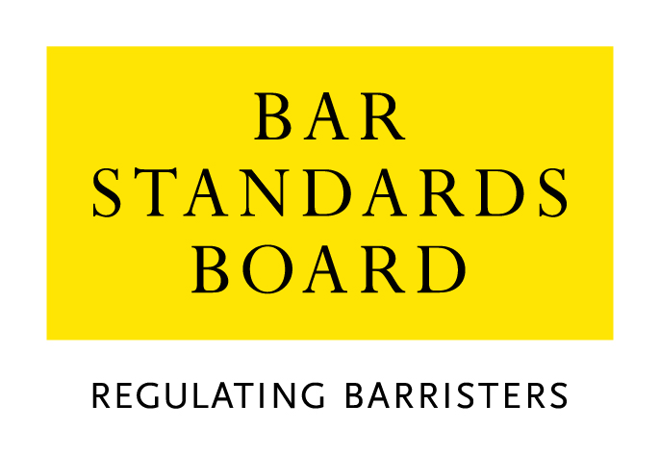

Equality & Diversity Monitoring Form

Diversity data gathered from this form will be anonymised and used to inform Bar Council and Bar Standards Board (BSB) policy aimed at widening access to the profession and improving diversity. It will assist the Bar Council and BSB in meeting our statutory duties under the Equality Act 2010 and will inform our wider equality and diversity strategy.

Your diversity data will be treated as confidential and stored securely according to the Bar Council’s Privacy policy. It will not be published in a way which might identify any individual. The raw data will be kept only for monitoring purposes.

Question formats are based on LSB approved monitoring questions.

Provision of diversity information is not compulsory however we strongly encourage you to help us by completing this form.

Please answer each question in turn by choosing one option only, unless otherwise indicated. If you do not wish to answer the question please choose the option ‘Prefer not to say’ rather than leaving the question blank.

1. Age

From the list of age bands below, please indicate the category that includes your current age in years:

16 - 24
25 - 34
35 - 44
45 - 54
55 - 64
65+
Prefer not to say

2. Gender

What is your gender?

Male
Female
Prefer not to say

3. Disability

The Equality Act 2010 generally defines a disabled person as someone who has a mental or physical impairment that has a substantial and long-term adverse effect on the person’s ability to carry out normal day-to-day activities.

(a) Do you consider yourself to have a disability according to the definition in the
Equality Act?

Yes
No
Prefer not to say

(b) Are your day-to-day activities limited because of a health problem or disability which has lasted, or is expected to last, at least 12 months?

Yes, limited a lot
Yes, limited a little
No
Prefer not to say

4. Ethnic group

What is your ethnic group?

Asian / Asian British

Bangladeshi
Chinese
Indian
Pakistani
Any other Asian background (write in)

Black / African / Caribbean / Black British

African
Caribbean
Any other Black / Caribbean / Black British (write in)

Mixed / multiple ethnic groups

White and Asian
White and Black African
White and Black Caribbean
White and Chinese
Any other Mixed / multiple ethnic background (write in)

White

British / English / Welsh / Northern Irish / Scottish
Irish
Gypsy or Irish Traveller
Any other White background (write in)

Other ethnic group

Arab
Any other ethnic group (write in)

Prefer not to say

Prefer not to say
5. Religion or belief

What is your religion or belief?

No religion or belief
Buddhist
Christian (all denominations)
Hindu
Jewish
Muslim
Sikh
Any other religion (write in)
Prefer not to say

6. Sexual orientation

What is your sexual orientation?

Bisexual
Gay man
Gay woman/lesbian
Heterosexual/straight
Other
Prefer not to say

7. Socio-economic background

(a) If you went to University (to study a BA, BSc course or higher), were you part of the first generation of your family to do so?

Yes
No
Did not attend University
Prefer not to say

(b) Did you mainly attend a state or fee paying school between the ages 11 – 18?

UK State School
UK Independent/Fee-paying School
Attended school outside the UK
Prefer not to say

8. Caring responsibilities

(a) Are you a primary carer for a child or children under 18?

Yes
No
Prefer not to say

(b) Do you look after, or give any help or support to family members, friends, neighbours or others because of either:

- Long-term physical or mental ill-health / disability
- Problems related to old age?

(Do not count anything you do as part of your paid employment)

No
Yes, 1 - 19 hours a week
Yes, 20 - 49 hours a week
Yes, 50 or more hours a week
Prefer not to say

Thank you for completing this questionnaire

See https://www.barstandardsboard.org.uk/privacy-statement.html

