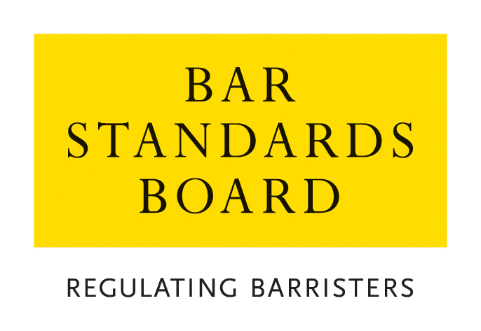

REGULATORY STANDARDS DEPARTMENT
AUTHORISATIONS TEAM

CRITERIA AND GUIDELINES FOR TEMPORARY ADMISSION AND CALL TO THE BAR

These Notes are divided into two sections:

Section A. Guidance Notes – General Procedure for applications and appeals
Section B. Criteria for applications

Nature of Application | Brief Summary
- Application for Temporary Admission and Call to the Bar | To allow an applicant to appear in court in England and Wales to conduct a specific case or cases only
A. Guidance Notes – General Procedure for applications and appeals

1 General
  - In these Notes, the Bar Standards Board and its staff are referred to as the “the BSB”. The BSB Handbook is referred to as “the Handbook”. The Bar Qualification Rules, which constitute Section 4B of the Handbook, are referred to as “BQR”.
  - These Notes set out the criteria and guidelines which the BSB applies in considering applications and should be read carefully and in conjunction with the Handbook.
- How applications are dealt with
  - Applications must be made on the appropriate application form. Please return the completed application form with accompanying documentation and payment of the application fee to authorisations@barstandardsboard.org.uk. If you are unable to submit your application by email, please contact us for further guidance.
  - All applications contain a declaration that the applicant has read, understood, and complied with these Criteria and Guidelines.
  - The declaration must be completed with a hand-written signature. If you have no access to scan and print the application form - please write out the declaration from the application form by hand, sign it, take a photo of the document and email that to us as evidence of your handwritten signature.
  - Applications are considered and determined under the powers of the Bar Standards Board. The Bar Standards Board has delegated to BSB staff the ability to take decisions within the criteria and guidelines set out in this document.
  - An applicant must ensure that all supporting evidence is sent with the application form. Where original certificates or certified copies are required, these must be emailed directly to the BSB by the awarding institution.
  - An application will not be treated as “complete” until the application form, required supporting documentation and application fee have been received. The BSB may request further information or documentation be supplied in support of an application, but applicants should note that it is the primary responsibility of the applicant to provide all relevant information and supporting evidence.
- Applicants should exercise judgement when selecting supporting evidence and ensure that only documentation that is relevant to the criteria set out in this document is supplied.
It is usually not appropriate to supply examples of work with an application. Any applicant who does supply such examples should ensure that documents that refer to third parties (e.g. clients) are suitably redacted so as to ensure anonymity. Any application that is supported by unredacted material will be returned to the applicant.
  - The BSB will take into account all the circumstances of the particular application and will apply the guidelines set out in these Notes.
  - All applications will be acknowledged in writing within seven days of receipt of the complete application form.
  - The BSB normally deals with all applications within eight weeks of receipt and notifies applicants of its decision within 10 days of a decision.
  - The BSB will treat all applications and any supporting documentation provided in the strictest confidence.
  - All enquiries about applications whether proposed or pending should be addressed to the BSB.
- Application Fee Payment
  - The application fees for each type of application and methods of payment are listed on the BSB website. The preferred method of payment is bank transfer (BACS). Once your application has been logged by the Authorisations Team, an invoice will be generated and sent to you by email to enable you to make a BACS payment. You must quote the invoice reference when making a payment by BACS.
  - If you are unable to pay by BACS, you may make payment by credit/debit card. Once you have received an email acknowledgement that your application has been logged, please call the Authorisations Team on 020 7611 1444 to make a card payment.
  - Details of the team’s Fee Waiver policy are available on the BSB website.
- Reviews and Appeals
  - Any applicant who is dissatisfied with a decision may request a review of the decision.
  - Any request for a review must be made on the designated application form and accompanied by the relevant application fee within one month of notification of the relevant decision and must be accompanied by the appropriate application fee. All requests will be acknowledged in writing within seven days of receipt.
  - Review Panels deal with reviews of decisions as if the application was being dealt with afresh, applying the guidelines set out in these Notes. A Review Panel shall be entitled to have such regard to the original decision, and to uphold, vary or take into account such decision, as in its absolute discretion it feels appropriate.
  - Applications for review are normally determined within 10 weeks of receipt. Should it not be possible to deal with a review within this timescale, the applicant will be notified.
  - All enquiries about reviews whether proposed or pending should be addressed to the BSB.
  - Where a Review Panel has determined a review of a decision, there is no procedure under the BQR for a further review. A Review Panel may review its own decisions under section B10 of the BQR but is not obliged to carry out such a further review. Any person dissatisfied with a determination of a Review Panel is advised to take independent legal or other appropriate advice.
  - Rule Q39 provides that where the BQR provide for a review by the BSB of a decision, no appeal may be made to the High Court unless such a review has taken place.
  - Rule Q40 provides that subject to Rule Q39, a person or organisation who is adversely affected by a decision of the BSB may appeal to the High Court, in accordance with the Civil Procedure Rules.

Online Resources
BSB website: www.barstandardsboard.org.uk
Applications forms and guidance notes: www.barstandardsboard.org.uk/training-qualification/barrister-training-waivers-and-exemptions.html

Contact details
authorisations@barstandardsboard.org.uk
B. Criteria for Applications

Application for Temporary Admission and Call to the Bar of Qualified Foreign Lawyers
Introduction
  - The expression “Qualified Foreign Lawyer” has the meaning ascribed to it in Part 6 of the Handbook:
“Qualified Foreign Lawyer” means a person who is a member of a legal profession regulated in a jurisdiction outside England and Wales and entitled to practise as such.
1.2 Any applicant who is seeking Temporary Admission and Call to the Bar as a Qualified Foreign Lawyer must apply to the BSB on the prescribed application form.
1.3 For details of the application fee, please refer to the Bar Standards Board website: www.barstandardsboard.org.uk/training-qualification/barrister-training-waivers-and-exemptions.html
Rules
  - The relevant rules governing applications to the BSB by Qualified Foreign Lawyers for Temporary Admission and Call to the Bar are Rules Q25-28.
Details
  - The applicant must be a Qualified Foreign Lawyer who has for a period of at least three years regularly exercised full rights of audience in courts which administer law substantially similar to the common law of England and Wales.
Information and Documentation
  - To obtain a Temporary Qualification Certificate, the applicant must provide
1.6.1 Evidence that the applicant is a Qualified Foreign Lawyer who has for a period of at least three years regularly exercised full rights of audience in courts which administer law substantially similar to the common law of England and Wales.
    - A Certificate of Good Standing
    - Evidence that a professional client wishes to instruct the applicant to appear as counsel in the case or cases in respect of which the applicant seeks temporary call. A letter from the professional client concerned is usually sufficient.
Guidelines
  - The applicant must be able to identify the cases in which the solicitors wish to instruct the applicant, and it is therefore helpful if the solicitors give that information.
  - Temporary Admission of an Inn of Court and Call to the Bar ends automatically on conclusion of the case or cases for which the applicant was temporarily called.

