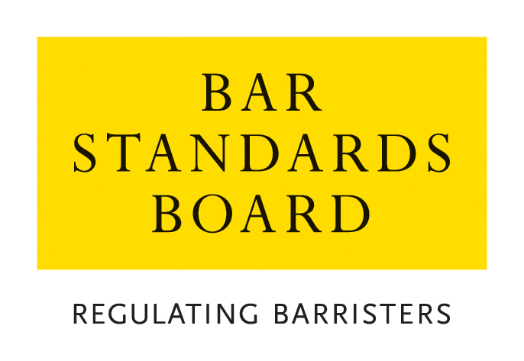

REGULATORY STANDARDS DEPARTMENT
AUTHORISATIONS TEAM

CRITERIA AND GUIDELINES FOR PUPILLAGE REDUCTION (BARRISTERS ALSO QUALIFIED AS SOLICITORS)

These Notes are divided into two sections:

Section A. Guidance Notes – General Procedure for applications and appeals
Section B. Criteria for applications

Nature of Application | Brief Summary
- Applications for Reduction in Work-based learning (pupillage) for Barristers who have also qualified as Solicitors | Applications by those who have both been called to the Bar and enrolled as a solicitor and who are seeking a reduction in work-based learning (pupillage)
A. Guidance Notes – General Procedure for applications and appeals

1 General
  - In these Notes, the Bar Standards Board and its staff are referred to as the “the BSB”. The BSB Handbook is referred to as “the Handbook”. The Bar Qualification Rules, which constitute Section 4B of the Handbook, are referred to as “BQR”.
  - These Notes set out the criteria and guidelines which the BSB applies in considering applications and should be read carefully and in conjunction with the Handbook.
- How applications are dealt with
  - Applications must be made on the appropriate application form. Please return the completed application form with accompanying documentation and payment of the application fee to authorisations@barstandardsboard.org.uk. If you are unable to submit your application by email, please contact us for further guidance.
  - All applications contain a declaration that the applicant has read, understood, and complied with these Criteria and Guidelines.
  - The declaration must be completed with a hand-written signature. If you have no access to scan and print the application form - please write out the declaration from the application form by hand, sign it, take a photo of the document and email that to us as evidence of your handwritten signature.
  - Applications are considered and determined under the powers of the Bar Standards Board. The Bar Standards Board has delegated to BSB staff the ability to take decisions within the criteria and guidelines set out in this document.
  - An applicant must ensure that all supporting evidence is sent with the application form. Where original certificates or certified copies are required, these must be emailed directly to the BSB by the awarding institution.
  - An application will not be treated as “complete” until the application form, required supporting documentation and application fee have been received. The BSB may request further information or documentation be supplied in support of an application, but applicants should note that it is the primary responsibility of the applicant to provide all relevant information and supporting evidence.
- Applicants should exercise judgement when selecting supporting evidence and ensure that only documentation that is relevant to the criteria set out in this document is supplied.
It is usually not appropriate to supply examples of work with an application. Any applicant who does supply such examples should ensure that documents that refer to third parties (e.g. clients) are suitably redacted so as to ensure anonymity. Any application that is supported by unredacted material will be returned to the applicant.
  - The BSB will take into account all the circumstances of the particular application and will apply the guidelines set out in these Notes.
  - All applications will be acknowledged in writing within seven days of receipt of the complete application form.
  - The BSB normally deals with all applications within eight weeks of receipt and notifies applicants of its decision within 10 days of a decision.
  - The BSB will treat all applications and any supporting documentation provided in the strictest confidence.
  - All enquiries about applications whether proposed or pending should be addressed to the BSB.
- Application Fee Payment
  - The application fees for each type of application and methods of payment are listed on the BSB website. The preferred method of payment is bank transfer (BACS). Once your application has been logged by the Authorisations Team, an invoice will be generated and sent to you by email to enable you to make a BACS payment. You must quote the invoice reference when making a payment by BACS.
  - If you are unable to pay by BACS, you may make payment by credit/debit card. Once you have received an email acknowledgement that your application has been logged, please call the Authorisations Team on 020 7611 1444 to make a card payment.
  - Details of the team’s Fee Waiver policy are available on the BSB website.
- Reviews and Appeals
  - Any applicant who is dissatisfied with a decision may request a review of the decision.
  - Any request for a review must be made on the designated application form and accompanied by the relevant application fee within one month of notification of the relevant decision and must be accompanied by the appropriate application fee. All requests will be acknowledged in writing within seven days of receipt.
  - Review Panels deal with reviews of decisions as if the application was being dealt with afresh, applying the guidelines set out in these Notes. A Review Panel shall be entitled to have such regard to the original decision, and to uphold, vary or take into account such decision, as in its absolute discretion it feels appropriate.
  - Applications for review are normally determined within 10 weeks of receipt. Should it not be possible to deal with a review within this timescale, the applicant will be notified.
  - All enquiries about reviews whether proposed or pending should be addressed to the BSB.
  - Where a Review Panel has determined a review of a decision, there is no procedure under the BQR for a further review. A Review Panel may review its own decisions under section B10 of the BQR but is not obliged to carry out such a further review. Any person dissatisfied with a determination of a Review Panel is advised to take independent legal or other appropriate advice.
  - Rule Q39 provides that where the BQR provide for a review by the BSB of a decision, no appeal may be made to the High Court unless such a review has taken place.
  - Rule Q40 provides that subject to Rule Q39, a person or organisation who is adversely affected by a decision of the BSB may appeal to the High Court, in accordance with the Civil Procedure Rules.

Online Resources

BSB website: www.barstandardsboard.org.uk

Applications forms and guidance notes:
https://www.barstandardsboard.org.uk/qualifying-as-a-barrister/bar-training-requirements/forms-and-guidelines/applications-authorisations,-exemptions,-waivers-and-reviews/

Contact details: authorisations@barstandardsboard.org.uk
B. Criteria for Applications

Application for Reduction in Work-based learning (pupillage) for a Barrister who has also qualified as a Solicitor
Introduction
1.1 A solicitor may apply to the BSB for exemption from the work-based learning (pupillage) component of training.
1.2 Applicants must apply to the BSB on the prescribed application form.
1.3 For details of the application fee, please refer to the Bar Standards Board website: www.barstandardsboard.org.uk/training-qualification/barrister-training-waivers-and-exemptions.html
Rules
1.4 The relevant rules governing these applications are contained in section B2.
Information and Documentation
1.5 The information and documentation which must be provided with the completed application form is as follows:
1.5.1 Particulars (1) of the educational or professional qualifications which entitled the solicitor to be admitted as a solicitor; (2) his or her admission; and (3) any period of practice as a solicitor
1.5.2 A certificate of good standing issued by the Law Society of England & Wales or the Law Society of Northern Ireland not more than three months old at the date of receipt of the application to the BSB.
1.5.3 A declaration in the form set out in the application form
1.5.4 Evidence (where applicable) that the solicitor is or has been entitled to exercise rights of audience as a solicitor, specifying the rights concerned and the manner in which the solicitor has or had become entitled to exercise such rights
1.5.5 Any other representation or evidence on which the solicitor may wish to rely in support of any application to be wholly or partially exempted from the work-based learning (pupillage) component of training prescribed by the BQR.
Guidelines
Solicitors with higher rights of audience in both civil and criminal proceedings
1.6 Solicitors with higher rights of audience in both civil and criminal proceedings:
1.6.1 Shall be wholly exempt from the work-based learning (pupillage) component of training.
Solicitors with higher rights of audience in either civil or criminal proceedings
1.7 Solicitors with higher rights of audience in either civil or criminal proceedings:
1.7.1 Shall be exempt from the work-based learning (pupillage) component of training unless the BSB determines (having regard in particular to the experience, previous practice and intended future practice of the solicitor) that there are exceptional circumstances applying to the solicitor, in which case the BSB may require the solicitor to undertake part, or all, of the practising period of work-based learning (pupillage).
Solicitors without higher court rights of audience
1.8 Solicitors without higher court rights of audience:
1.8.1 Solicitors without higher court rights of audience will almost always be required to undertake at least some period of work-based learning (pupillage).
1.8.2 A newly qualified solicitor will usually be required to undertake six months of non-practising pupillage and six months of practising pupillage.
1.8.3 A solicitor of less than five years’ experience will usually be required to undertake three to six months of non-practising pupillage and six months of practising pupillage.
1.8.4 A solicitor of more than five years’ experience may be exempted from the whole of the non-practising period of pupillage or required to undertake up to three months of such period and will usually also be required to undertake three months of practising pupillage.
1.8.5 In determining the precise period of work-based learning (pupillage) to be required in any case the BSB will take into account the nature and extent of the solicitor’s experience, including in particular the amount of advocacy experience.
1.8.6 If a solicitor has been out of practice for a significant period the BSB will take that fact into account when determining the precise period of work-based learning (pupillage) to be undertaken.
Compulsory Courses
1.9 Applicants required to undertake any period of non-practising period of work-based learning (pupillage) will usually be required to undertake the Pupils’ Advocacy Course.
1.10 All applicants will usually be required to undertake the New Practitioners Programme during their first three years of practice as a barrister, including the Advocacy and Ethics sections.

