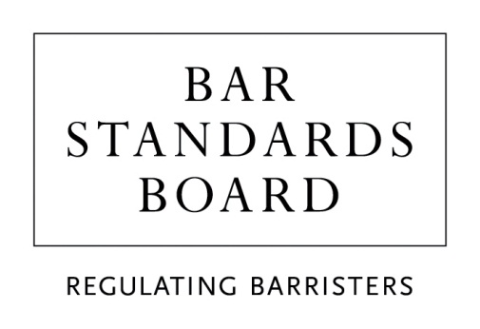

Bar Training

Professional Ethics examination during pupillage/work-based learning

Examination Misconduct Appeals Form
Should you need this form in a different format or assistance completing this form, please contact us via EthicsExam@BarStandardsBoard.org.uk or 020 7611 1444.
You should complete this form if you are seeking to appeal against a decision made by the Professional Ethics Examination Misconduct Panel.
Before completing this form, you must refer to the Professional Ethics Examination Misconduct Policy and Procedure, which can be found on our website.
Please note that an appeal must be made within 20 working days of the date on which the decision of the Misconduct Panel is sent to you by the BSB.

Please note all fields are mandatory.

Personal details
Date of exam
MyBar ID
Name
Telephone number
Email address

Please specify the decision which you are appealing against

Please select the reason why you believe the Misconduct Panel’s decision is wrong
☐ | I believe there was a failure in the decision-making process (eg the Misconduct Panel not taking into account all the relevant evidence available to it)
☐ | I believe the Misconduct Panel’s decision was irrational or biased
☐ | I believe there is additional evidence of new material circumstances, which was not previously available or there was good reason for it not being submitted before the decision of the Misconduct Panel was made
☐ | I have some other reason for believing the decision of the Misconduct Panel was wrong

Please provide a brief statement outlining in more detail your reasons for believing that the Misconduct Panel’s decision is wrong

Evidence and Additional Documents
Please list and briefly describe any document(s) you are submitting in support of your appeal (eg further statements or material evidence)
List and description of document(s):

Are you content for your appeal to be dealt with on the papers or do you wish to have an oral hearing?
☐ | I am content for the appeal to be dealt with on the papers
☐ | I wish to have an oral hearing

Data Protection
Personal data on this form will be used by the BSB for the purpose of considering appeals against a decision made by the Professional Ethics Examination Misconduct Panel. The information provided in this form, and any additional supporting information that you (the candidate) provide, will be held by the BSB Examinations Team in accordance with the UK General Data Protection Regulation and the Data Protection Act 2018. It will only be shared with members of the Appeal Panel. The personal information on this form and accompanying documentary evidence will only be retained until such time as you have been issued a full practising certificate or two years after it was received by the BSB, whichever is earlier. Once you have received a full practising certificate, or two years has passed, all personal information related to your appeal of a decision made by the Professional Ethics Examination Misconduct Appeal Panel will be confidentially destroyed/deleted.

You have a right to access your personal data and rectify any inaccuracies. If you would like to exercise these rights or have any concerns about the way your personal data are being handled, please send an e-mail to EthicsExam@barstandardsboard.org.uk. You can also contact the Data Protection Officer at privacy@barcouncil.org.uk.

Declaration
I declare that the information given in this form is true to the best of my knowledge and that I am willing to answer further questions relating to it if it is necessary to do so to enable the Exams Team to understand my circumstances.

I have read the Bar Standards Board’s Privacy Statement and understand how my data will be handled. I have read and understood the Professional Ethics Examination Misconduct Policy and Procedure
Candidate signature
Date
Your appeal form and accompanying evidence should be submitted to EthicsExam@barstandardsboard.org.uk

