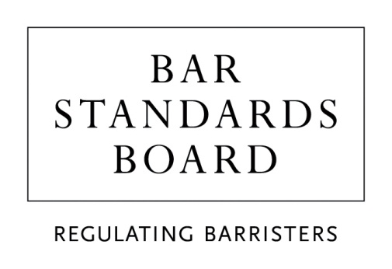

Bar Training

Professional Ethics examination during pupillage/work-based learning

Adjustments and other arrangements request form

Should you need this form in a different format, or assistance completing this form please contact us via EthicsExam@barstandardsboard.org.uk or 020 7611 1444.

You should complete this form if you are seeking an adjustment on the grounds of a disability or other condition (whether temporary or permanent) or other arrangement for the Professional Ethics examination.

Before completing this form please refer to the Professional Ethics Adjustments and Other Arrangements Policy and Procedures, which can be found on our website.

The BSB has obligations under the Equality Act 2010 to provide reasonable adjustments. Please refer to paragraphs 2.1, 2.2, and 8.7 in the Professional Ethics Adjustments and Other Arrangements Policy and Procedures for more details about these obligations and the definition of reasonableness.

Once any adjustments have been agreed, we will let you know whether you need to book your own exam via the Scheduler booking portal or whether we will need to book it for you. The nature of the adjustment will determine this.

Completed forms must be submitted at least two weeks before the exam booking window opens. Please see the advertised deadlines for this session on our website. The BSB cannot guarantee adjustments and arrangements which are not applied for within the specified timeframe or do not contain the relevant evidence.

Please note ALL fields are mandatory.

Personal details
Date of exam
MyBar ID
Name
Telephone number
Email address
Preferred exam delivery method
(Online Proctored / Test Centre)
Will you be attempting the exam in the UK (Yes/No)? If No, in which country do you plan on attempting the exam?

Adjustments or arrangements requested
Please tick () and complete as appropriate

Please note documentary evidence must be submitted which confirms the adjustments that should be put in place for your examination

Time and breaks
Please note extensions of time are offered in accordance with the evidence supplied.
Extra time - Please select % | 25% ☐ / 50% ☐ / 75% ☐ / 100% ☐ / Other ☐  If “Other” please specify: ______%
Breaks – Please specify (eg Five minute break every hour to stand and stretch)

Visual adjustments
Please specify if you require the use of Windows Magnifier
(NB: browser zoom controls are available as a default and do not need to be applied for)
Please specify if you require a specific font type or size
Different background / paper colour - Please specify colour
Please see the standard font colours and screen colours all candidates can select before the test, listed in section 1 on Annex A of the Professional Ethics Adjustment and Other Arrangements Policy and Procedures. If you require a font or background colour not listed in Annex A, please request a pen and paper exam below.

Adjustments provided at a test centre
Please note the following adjustments can only be offered in a test centre.
A separate/private room
(We may need to contact you to discuss the location where you wish to sit, as not all test centres have private rooms.)
Support for JAWS or Dragon Naturally Speaking
Support for Windows Magnifier
A Reader who can read the questions out loud to you
A Scribe who can record your responses on the computer
The exam in pen and paper format (for example if font or colour options outside of the standard options are required)
The exam in Braille format
Please indicate your preferred location(s) or city (in order of preference):

Any other adjustments or arrangements
Please specify your request here. You must include evidence to support your requested adjustment. NB: If the arrangement relates to head coverings or gender identity or expression, you do not need to provide evidence.

Documentary evidence
Please list and briefly describe the document(s) you are submitting in support of your request and the number of documents you have enclosed.
List and description of document(s)

Declaration
I declare that the information given in this form is true to the best of my knowledge and that I am willing to answer further questions relating to it if it is necessary to do so to enable the Exams team to understand my requirements.
I have read the Bar Standards Board’s Privacy Statement and understand how my data will be handled.
Candidate Signature
Date
Your request form and the accompanying evidence should be submitted to EthicsExam@BarStandardsBoard.org.uk

Data Protection
Personal information on this form will be used by the BSB for the purpose of providing adjustments or exceptional arrangements for the Professional Ethics examination. The information provided in this form, and any additional supporting information that you (the candidate) provide, will be held by the BSB Examinations Team in accordance with the UK General Data Protection Regulation and the Data Protection Act 2018. It will only be shared with members of a small advisory group if further discussion is required. If your request is granted, your approved adjustment/arrangement will be communicated to BTL/Surpass who provide the platform on which you will take your exam and will need to put the agreed adjustment in place. If you wish to appeal a decision, then your data will be shared with the Appeals Panel. The personal information on this form and accompanying documentary evidence will only be retained until such time as you have been issued with a full practising certificate or two years after they were received by the BSB, whichever is earlier. Once you have received a full practising certificate, all personal information related to your request for adjustment will be confidentially destroyed/deleted.

You have a right to access your personal data and rectify any inaccuracies. If you would like to exercise these rights or have any concerns about the way your personal data are being handled please send an email to: EthicsExam@barstandardsboard.org.uk. You can also contact the Data Protection Officer at privacy@barcouncil.org.uk.

